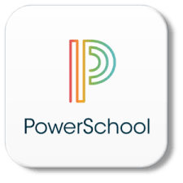

PowerSchool
PARENT & STUDENT PORTAL

Our school uses PowerSchool, which is an online gradebook. Please use the directions on the back of this sheet to access your child’s PowerSchool information. You will be able to view your child’s grades, any grade changes, and missing work at any time. You have the option to download the app on your phone and set alerts to keep up with your child’s progress and performance at school. You can also access grades from a computer. Parents/guardians have the ability to create an account that will allow you to access all of your accounts from a single login. You can create your own Username and Password which you will be able to use every year until your child graduates.

Be sure to keep your Username and Password in a secure location
as it will follow your child all the way through high school.

Student Access ID

Access Password

If you already have an account but need to add a new child to your account:
Log into ParentPortal, choose ‘Account Preferences’, select the ‘Students’ tab, and then add your child using the Access ID & Access Password provided. If you have more than one child on your account, you can switch between each child by clicking on the child’s name that appears in the blue menu bar at the top of the page.

How to Create a Parent Portal Account

- Choose one of the options below to access Parent Portal.
- https://bedford.powerschool.com/public/home.html
- Go to the county or your school’s webpage and then Click on “Quick Links” and then “Parent Portal” to login
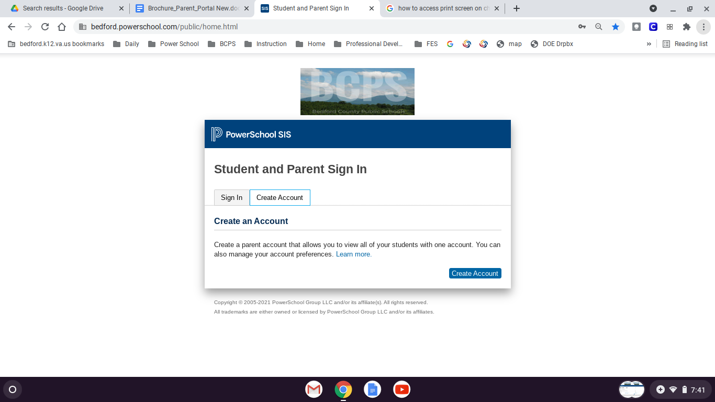
- Click the tab “Create Account” and then click the blue button “Create Account”.

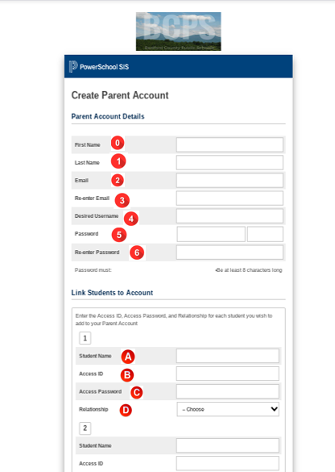
- Complete the required fields. Your child’s Access ID and Access Password are on the front of this sheet. Scroll down and click submit.

- First Name
- Last Name
- Email
- Re-enter Email
- District Username [SWPG]
- Password
- Re-enter Password

- Student Name
- Access ID
- Access Password
- Relationship

